# Tutorial 4

# HMIS:

First created HMIS db from file

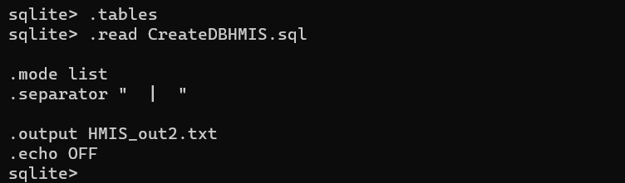

Subquery 1 :

SELECT State || “ --- “ || Application || “---” || Status AS “New_England_App_Status”, COUNT(*)

FROM ( SELECT Name, Application, Status, City, State

FROM ( SELECT Name, Application, Status, City, State

FROM LEADS

WHERE State = “ME” OR State = “NH” OR State = “VT” OR

State = “NY” OR State = “MA” OR State = “NJ” OR State = “CT” OR

State = “RI”)

WHERE Status = “Not Automated” )

GROUP BY New_England_App_Status

ORDER BY New_England_App_Status, COUNT(*);

Subquery 2:

SELECT City || “---” || Application || “ --- “ AS “App_Stat_Top_Urban_TX”, Status, COUNT(*)

FROM ( SELECT Name, Application, Status, City, State

FROM ( SELECT Name, Application, Status, City, State

FROM LEADS

WHERE State = “TX”)

WHERE City IN (“Houston”, “Dallas”, “Austin”, “Fort Worth”, “El Paso”,

“San Antonio”, “McCallen”))

GROUP BY App_Stat_Top_Urban_TX, Status

HAVING Status = “Not Automated”

ORDER BY App_Stat_Top_Urban_TX, COUNT(*);

Subquery 3 :

SELECT City || “---” || Application || “ --- “ || Status AS “App_Stat_Rural_TX”, COUNT(*)

FROM LEADS

WHERE State = “TX” and City IN ( SELECT CITY

FROM LEADS

WHERE State = “TX” AND City NOT IN (“Houston”, “Dallas”, “Austin”,

“Fort Worth”, “El Paso”, “San Antonio”, “McCallen”))

GROUP BY App_Stat_Rural_TX

HAVING Status = “Not Automated”

ORDER BY App_Stat_Rural_TX, COUNT(*)

LIMIT 50;

Select projection :

CREATE TABLE TX_DALLAS_HOSPITALS AS

SELECT *

FROM LEADS

WHERE State = “TX” AND City = “Dallas”;

SELECT Entity_No, Name, Zip, Application || “---” || Status As AppStat

FROM TX_DALLAS_HOSPITALS

WHERE Status = “Live and Operational”

ORDER BY ZIP

LIMIT 10;

Select projection to create csv file:

.headers on

.mode csv

.output file_one.csv

SELECT Entity_No, Name, Zip, Application || “---” || Status As AppStat

FROM TX_DALLAS_HOSPITALS

WHERE Status = “Live and Operational”

ORDER BY ZIP;

# Sales_Co_DW:

Created db from reading file:

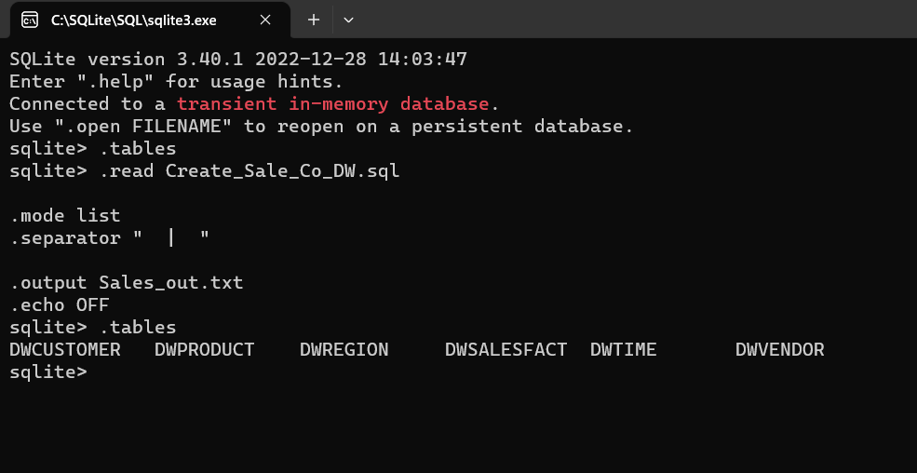

Subquery 1:

SELECT V_STATE || '--' || TRIM(V_NAME) || '--' || TRIM(P_DESCRIPT) AS 'State-Vendor-Product',

V_STATE, SUM(DWSALESFACT.SALE_UNITS), COUNT(DWSALESFACT.SALE_UNITS)

FROM DWVENDOR, DWPRODUCT, DWSALESFACT

WHERE DWVENDOR.V_CODE = DWPRODUCT.V_CODE AND DWPRODUCT.P_CODE =

DWSALESFACT.P_CODE AND DWVENDOR.V_CODE IN (SELECT V_CODE

FROM DWVENDOR WHERE V_STATE IN

(SELECT V_STATE FROM DWREGION, DWCUSTOMER, DWVENDOR, DWPRODUCT,

DWSALESFACT

WHERE DWREGION.REG_NAME = 'SE' AND

DWREGION.REG_ID = DWCUSTOMER.REG_ID AND

DWCUSTOMER.CUS_CODE = DWSALESFACT.CUS_CODE AND

DWSALESFACT.P_CODE = DWPRODUCT.P_CODE))

GROUP BY V_STATE, 'State-Vendor-Product'

ORDER BY V_STATE;

Subquery 2 :

SELECT V_STATE || '--' || TRIM(V_NAME) || '--' ||

TRIM(P_DESCRIPT) AS 'State-Vendor-Product', V_STATE, SUM(DWSALESFACT.SALE_UNITS),

COUNT(DWSALESFACT.SALE_UNITS)

FROM DWVENDOR, DWPRODUCT, DWSALESFACT

WHERE DWVENDOR.V_CODE = DWPRODUCT.V_CODE AND

DWPRODUCT.P_CODE = DWSALESFACT.P_CODE AND

DWVENDOR.V_CODE = (SELECT V_CODE FROM DWVENDOR

WHERE V_STATE = (SELECT V_STATE FROM DWREGION, DWCUSTOMER,

DWVENDOR, DWPRODUCT, DWSALESFACT

WHERE DWREGION.REG_NAME = 'SE' AND

DWREGION.REG_ID = DWCUSTOMER.REG_ID AND

DWCUSTOMER.CUS_CODE = DWSALESFACT.CUS_CODE AND

DWSALESFACT.P_CODE = DWPRODUCT.P_CODE))

GROUP BY V_STATE, 'State-Vendor-Product'

ORDER BY V_STATE;

Subquery 3:

SELECT DWVENDOR.V_STATE || '--' || TRIM(DWVENDOR.V_NAME) || '--' ||

TRIM(P_DESCRIPT) AS StateVendorProduct, DWVENDOR.V_STATE,

SUM(DWSALESFACT.SALE_UNITS), COUNT(DWSALESFACT.SALE_UNITS)

FROM DWVENDOR, DWPRODUCT, DWSALESFACT

WHERE DWVENDOR.V_CODE = DWPRODUCT.V_CODE AND

DWPRODUCT.P_CODE = DWSALESFACT.P_CODE AND

DWPRODUCT.V_CODE IN

( SELECT DWPRODUCT.V_CODE FROM DWREGION, DWVENDOR,

DWCUSTOMER, DWVENDOR, DWPRODUCT, DWSALESFACT

WHERE DWREGION.REG_NAME = 'SE' AND

DWREGION.REG_ID = DWCUSTOMER.REG_ID AND

DWCUSTOMER.CUS_CODE = DWSALESFACT.CUS_CODE AND

DWSALESFACT.P_CODE = DWPRODUCT.P_CODE)

GROUP BY V_STATE, StateVendorProduct

ORDER BY V_STATE;

Select projection :

SELECT DISTINCT DWPRODUCT.P_CODE AS P_CODE, DWPRODUCT.P_DESCRIPT AS P_DESC, DWPRODUCT.P_CATEGORY AS P_CAT, DWPRODUCT.V_CODE AS V_CODE,

DWVENDOR.V_Name AS P_Vendor, DWSALESFACT.SALE_UNITS AS UNITS, DWSALESFACT.SALE_PRICE AS PRICE

FROM DWVENDOR, DWPRODUCT, DWSALESFACT

WHERE DWVENDOR.V_CODE = DWPRODUCT.V_CODE AND

DWPRODUCT.P_CODE = DWSALESFACT.P_CODE;

Select projection to create .csv file :

.headers on

.mode csv

.output file_two.csv

SELECT *

FROM DWPRODUCT

ORDER BY DWPRODUCT.P_CODE, DWPRODUCT.P_DESCRIPT;

# QC_Checks_db:

.open QC_Checks.db

.headers on

.separator “ | “



Subquery 1:

SELECT Check_ID || “ --- ” || Staff || “—“AS ERR, COUNT(*) FROM ERRORS

WHERE Staff IN (SELECT Staff FROM ERRORS

WHERE Check_ID IN (SELECT Check_ID FROM ERRORS

GROUP BY Check_ID

ORDER BY COUNT(*) DESC

Limit 5)

GROUP BY Staff

ORDER BY COUNT(*) DESC

LIMIT 5)

GROUP BY ERR

ORDER BY ERR, COUNT(*);

Subquery2:

SELECT Check_ID || “ — “ || SUBSTR(QC_Note,1,70) || “ --> “AS ERR, COUNT(*) FROM ERRORS

WHERE Check_ID IN (SELECT Check_ID FROM ERRORS

WHERE Staff == (SELECT Staff FROM ERRORS

GROUP BY Staff

ORDER BY COUNT(*) DESC

Limit 1)

GROUP BY Check_ID

ORDER BY COUNT(*) DESC)

GROUP BY ERR

HAVING COUNT(*) > 2

ORDER BY COUNT(*) DESC , ERR ASC;

Subquery 3 :

SELECT Check_ID || “ —> “ AS ERR, COUNT(*) FROM ERRORS

WHERE Check_ID NOT IN (SELECT Check_ID FROM ERRORS

WHERE Staff == (SELECT Staff FROM ERRORS

GROUP BY Staff

ORDER BY COUNT(*) DESC

Limit 1)

GROUP BY Check_ID

ORDER BY COUNT(*) DESC)

GROUP BY ERR

ORDER BY COUNT(*) DESC ;

Select projection :

CREATE TABLE QC_Check_Errs AS

SELECT Check_ID, Staff, COUNT(*) FROM ERRORS

GROUP BY Check_ID, Staff

HAVING COUNT(*) > 1

ORDER BY COUNT(*) DESC ;

SELECT * FROM QC_Check_Errs;

Select projection to create csv file :

.headers on

.mode csv

.output file_three.csv

SELECT Check_ID, COUNT(*)

FROM ERRORS

GROUP BY Check_ID

ORDER BY COUNT(*) DESC;

